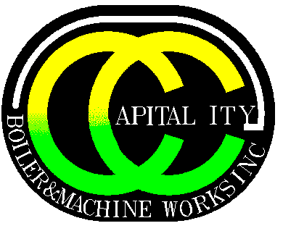

**Capital City Boiler & Machine Works, Inc.**

**2600 E. Market Street - Des Moines, IA 50317**

**Phone: 515-265-9989 Fax: 515-265-1571**

**CURRENT POSITIONS**

**BOILERMAKER HELPER**

JOB SUMMARY:

As a Welder Helper you will report directly to the welder and will be responsible for assisting the Welder join or connect various types of metal parts. The Helper will operate both hand and power tools, while working in all types of inclement weather conditions. Job tasks and assignments may vary on a daily basis.

PRIMARY RESPONSIBILITIES:

* Lifts, moves, holds, clamps, pipe and fittings
* Squares and levels structural and pipe fittings for welding
* Cleans weld joints to remove impurities such as slag, rust, and grease, using wire brush or portable grinder
* Connects hoses from hand torch and beveling machine to oxygen and fuel gas cylinders or connects cables from power source to electrode holder
* Operates cutting torch and beveling machine
* Starts diesel engine to active welding generators
* Cleans welds of slag and metal debris
* Tags or marks finished spools
* May attach slings to finished spools to move out of work area
* Maintain orderly work area and help welder roll up to change work location
* Performed required installations as per project specifications
* Implemented lockout procedures and ensured safety always
* Assisted to disassemble and remove any damage or worn out pipe
* Installed various piping with help of hand and power tools on regular basis
* Assisted in transportation of materials, supplies and related equipment
* Analyze and identified any safety hazards and recommended appropriate actions
* Installed and connected components to perform tests on pipefitting projects
* Monitored industrial projects and interpreted requirement of tools and equipment
* Monitored and installed pipes that penetrate walls and ceilings
* Coordinated with pipe welder and assisted in welding of pipes
* Inspected worksite and established appropriate plans to avoid obstructions
* Ensured compliance to drawings and job specifications for projects