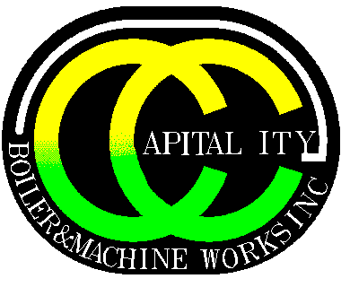

**Capital City Boiler & Machine Works, Inc.**

**2600 E. Market Street - Des Moines, IA 50317**

**Phone: 515-265-9989 Fax: 515-265-1571**

**CURRENT POSITIONS**

**PIPEFITTER**

JOB SUMMARY:

As a pipefitter you are responsible for the fabrication, installation, maintenance, and repair of all types of pipes and related materials. This includes installing hot water and steam heating systems, refrigeration, air conditioning, oil burners, stokers, power piping, welding, industrial process piping, pneumatic and digital temperature control equipment, high and low-pressure boilers, pneumatic piping, hydraulic piping and system commissioning.

PRIMARY RESPONSIBILITIES:

● Read blueprints and specification to determine the scope of work: locations, quantities, and material specs

• Selects type and size of pipe, and related materials and equipment according to specifications

• Cuts, threads, bends and assembles the pipes

• Prepare, cut, fabricate, layout, fit, position, and assemble piping components together in various positions

• Bolt, clamp, and tack-welds parts to secure in position for welding

• Install hangers, supports, valves and components according to piping system plans and specifications

• Perform leak tests to ensure the quality of the pipe and the piping systems

• Proper identification and use of tools required for tasks. (grinders, drills, beveling machine, etc.)

• Operate forklifts & overhead cranes

• Hoist loads using slings, chains, shackles, hooks, cables, and other rigging equipment

• Maintain safe and clean work environment