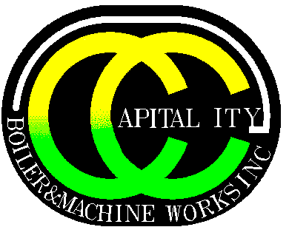

**Capital City Boiler & Machine Works, Inc.**

**2600 E. Market Street - Des Moines, IA 50317**

**Phone: 515-265-9989 Fax: 515-265-1571**

**CURRENT POSITIONS**

**COMBO PIPE WELDER**

JOB SUMMARY

As a Combo Pipe Welder you will be responsible for using Mig, Tig and flux core welding techniques to weld various components in flat, vertical, or overhead positions

PRIMARY RESPONSIBILITIES:

* Selects type and size of pipe or other related materials and equipment according to specifications
* Selects equipment and plans layouts, assembly, and welding, applying knowledge of geometry, physical properties of metal machining, and welding techniques
* May be required to use Gas-Metal Arc, Flux-Cored Arc, Gas-Tungsten Arc, Submerged Arc, or Shielded Metal Arc welding processes
* Lays out, positions, aligns and fits components together in various body positions
* Bolts, clamps and welds together metal components of products such as piping systems, plate, pipe and tube or structural shapes, using arc and arc gas welding equipment
* May weld in flat, horizontal, vertical, or overhead position
* May tack weld assemblies together
* Connects cable from welding unit to obtain amperage, voltage, slope and pulse as specified by procedure or supervisor
* Obtains specified electrode and inserts electrode into portable holder or threads consumable electrode wire through portable welding gun
* Starts power supply to produce electric current
* Strikes arc which generates heat to melt and deposit metal from electrode to work piece and join edges of work piece
* Manually guides electrode or gun along weld-line, maintaining length of arc and speed and movement to form specified depth of fusion and bead, as judged from color of metal, sound of weld, and size of molten puddle
* May manually apply filler rod to supply weld metal
* May clean or degrease weld joint or workplace, using wire brush, portable grinder, or chemical bath
* May repair broken or cracked parts and fill holes
* May remove excess weld, defective weld material, slag and spatter, using carbon arc gouge, hand scrapper, grinder or power chipper
* May preheat work piece, using hand torch or heating furnace
* May cut metal plates or structural shapes
* Examines weld for bead size and other specifications
* Loads, transports and unloads material, tools, equipment and supplies
* May assist in lifting, positioning and securing of materials and work pieces during installation
* Performs minor maintenance or cleaning activities of tools and equipment
* Assists other mechanics as needed
* Respiratory protection is common and may be required
* Required to pass employer performance tests or standard tests to meet certification standards
* Performs only procedures certified in
* Responsible for observing and complying with all safety and project rules
* Performs other duties as required